

**Data Technician**

|  |
| --- |
|  |

|  |
| --- |
| Name: Alaa Mostafa |
| Course Date: 08/09/25 |
|  |

**Table of contents**

Day 1: Task 1 2

Day 2: Task 1 2

Day 2: Task 2 3

Day 2: Task 3 4

Day 3: Task 1 4

Day 3: Task 2 5

Dataset: 5

Step 1: Create a Pivot Table 5

Step 2: Use the SWITCH Function 5

Submission: 6

Day 3: Task 3 6

Day 4: Task 1 7

Course Notes 9

Additional Information 10

# Day 1: Task 1

Please complete the below boxes on commons laws and regulations that must be followed when working with customers data, use the below bulleted list to support your answers.

* What is it
* Why is it important
* Provide a real-world example of how you can follow it
* How does it impact working with data
* What could happen if you breached it

|  |  |
| --- | --- |
| Data Protection Act | **What is it?** The **Data Protection Act 2018** is UK legislation that controls how personal data is collected, stored, used, and shared. It works alongside the **UK GDPR** to protect individuals’ privacy. **Why is it important?** It safeguards people’s personal information, ensures organisations use data fairly and lawfully, and helps build trust between the public and organisations. **Real-world example of following it** If you work in a school and handle pupil records, you must keep them secure (e.g. password-protected systems), only share information with authorised staff, and not disclose details to others without consent or a legal reason. **How does it impact working with data?** It sets strict rules on:   * Collecting only necessary data * Keeping it accurate and up to date * Storing it securely * Not keeping it longer than needed * Giving individuals rights over their data (e.g. access requests)  **What could happen if you breached it?**  * Legal action and fines (the ICO can issue penalties in the millions) * Loss of public trust and reputation damage * Disciplinary action at work, including dismissal * Risk of personal data being misused or stolen |
| GDPR | **What is it?** The **General Data Protection Regulation (GDPR)** is an EU law (adopted into UK law after Brexit as **UK GDPR**) that sets strict rules on how organisations collect, use, and protect personal data. **Why is it important?** It strengthens privacy rights, ensures data is handled lawfully and transparently, and gives people control over how their information is used. **Real-world example of following it** A business collecting customer emails must ask for **clear consent**, explain what they’ll be used for (e.g. newsletters), and allow customers to opt out at any time. **How does it impact working with data?**  * Requires **lawful basis** for processing data (consent, legal obligation, contract, etc.) * Organisations must keep data **secure, accurate, and only for as long as necessary** * Individuals have rights such as **access, correction, deletion, and objection** * Breaches must be reported to the ICO within **72 hours**  **What could happen if you breached it?**  * Severe fines (up to £17.5m or 4% of global turnover) * Legal consequences and compensation claims * Reputational damage and loss of trust * Internal disciplinary action |
| Freedom of Information Act | **What is it?** The **Freedom of Information Act 2000 (FOIA)** is UK legislation that gives the public the right to access information held by public authorities. **Why is it important?** It promotes **openness, transparency, and accountability**, allowing people to see how decisions are made and how public money is spent. **Real-world example of following it** If someone requests details of council spending on community projects, the council must provide the information (unless exempt) within **20 working days**. **How does it impact working with data?**  * Public bodies must have systems to record, manage, and release information. * Staff need to distinguish between information that can be shared and that which is exempt (e.g. personal data, national security). * Encourages proactive publication of key information.  **What could happen if you breached it?**  * Complaints and investigations by the **Information Commissioner’s Office (ICO)** * Legal challenges and possible court action * Loss of public trust and reputational damage * Internal disciplinary action for staff mishandling requests |
| Computer Misuse Act | **What is it?** The **Computer Misuse Act 1990** is UK legislation designed to prevent unauthorised access to computer systems and protect against cybercrime. **Why is it important?** It helps protect individuals, businesses, and governments from hacking, data theft, malware, and other cyber threats, ensuring systems and information remain secure. **Real-world example of following it** If you work in an office, you should only access files and systems you are authorised to use, and never attempt to bypass security controls like passwords or firewalls. **How does it impact working with data?**  * Sets clear boundaries on what staff can and cannot access. * Helps enforce cybersecurity policies in workplaces. * Encourages organisations to monitor and secure networks against misuse.  **What could happen if you breached it?**  * Criminal prosecution, with penalties ranging from fines to prison sentences. * Loss of employment and professional reputation. * Civil claims for damages if harm is caused to organisations or individuals. |

# Day 2: Task 1

Please research and complete the following tasks within the retail-sales_dataset.xlsx document, paste a print screen into the provided boxes below:

1. In the sheet ‘retail_sales_dataset’ add all available data between columns A –J into a ‘table’
2. Using the ‘sort’ function, sort ‘Age’ to ‘largest to smallest’
3. Using the ‘SUM’ function, show me the commission total in cell ‘L10’
4. Using the ‘AVERAGE’ function, show me the average commission in cell ‘L11’

|  |  |
| --- | --- |
| Print screen 1 |  |
| Print screen 2 |  |
| Print screen 3 |  |
| Print screen 4 |  |

# Day 2: Task 2

Please research and complete the following tasks within the retail-sales_dataset.xlsx document, paste print screens into the provided box below:

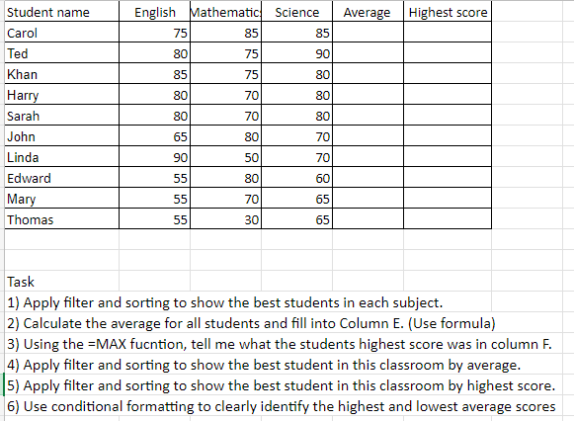

|  |  |
| --- | --- |
| Print screen 1 |  |

# Day 2: Task 3

Using the skills developed today, have some fun with the data set you have imported. Paste your work below and enjoy!

|  |  |
| --- | --- |
| Print screen 1 |  |

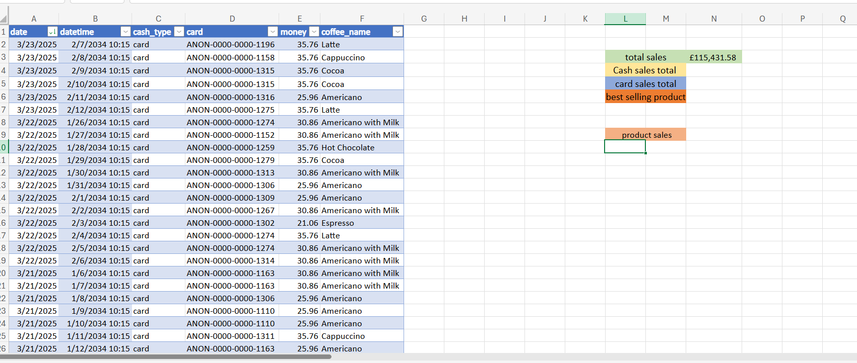

# Day 3: Task 1

Please download the dataset ‘Day_3_Task_1_Bike_Sales_Pivot_Lab.xlsx’ and the lab instructions.

Do not worry if you do not complete the lab, just working with data and playing with the pivot table will be good experience.

Please paste your final pivot table below and complete the reflection questions:

|  |  |
| --- | --- |
| Print screen 1 |  |
| In which markets does Germany have customers? | MOUTAIN BIKE 200 SILVER |
| What country has sales in all markets? | NON |
| What are the most profitable markets by country, age group, and gender? | MOUTAIN BIKE 200 FEMALE AUSTRAILIA {35-64} |
| Any other findings? | FEMALE ADULT IN AMERICA BOUGHT THE MOST BIKE IN AMERICA AGE 35-64 |

# Day 3: Task 2

The dataset below tracks the sales performance of different products in various counties in England. Please paste the dataset into a blank Excel workbook. Your task is to:

* **Create a Pivot Table** to summarise the data by county and product.
* **Use the SWITCH function** to categorise products based on their sales volume.

#### **Dataset:**

|  |  |  |
| --- | --- | --- |
| **County** | **Product** | **Sales Volume** |
| Yorkshire | Laptops | 500 |
| Yorkshire | Smartphones | 200 |
| Cornwall | Laptops | 700 |
| Cornwall | Printers | 400 |
| Lancashire | Smartphones | 150 |
| Lancashire | Laptops | 600 |
| Essex | Printers | 800 |
| Essex | Smartphones | 300 |
| Durham | Laptops | 250 |
| Durham | Printers | 300 |
| Greater Manchester | Smartphones | 600 |
| Greater Manchester | Laptops | 400 |

#### **Step 1: Create a Pivot Table**

* Select the dataset (columns A to C).
* Insert a Pivot Table to summarise the data by **County** in the rows and **Products** in the columns. Use **Sales Volume** as the value to be summarised.

#### **Step 2: Use the SWITCH Function**

In a new column next to your data, use the SWITCH function to categorise products based on **Sales Volume** as follows:

* + For sales greater than 600: **"High"**
  + For sales between 300 and 600: **"Medium"**
  + For sales less than 300: **"Low"**

**SWITCH Function Example**:

=SWITCH(TRUE, C2 > 600, "High", C2 >= 300, "Medium", "Low")

* Apply this formula to each row, and check if the products are categorised correctly.

#### **Submission:**

* A completed Pivot Table summarising sales by county and product.
* A new column in the dataset categorising products by sales volume using the SWITCH function.
  + Please paste your completed work below

|  |  |
| --- | --- |
| Print screen 1 | Excel online ot changing data type |

# Day 3: Task 3

Please download the dataset ‘Day_3_Task_3_Bike_Sales_Visualisations_Lab.xlsx’ and the the lab instructions. Do not worry if you do not complete the lab, just working with data and playing with the charts will be good experience.

Please paste your results below:

|  |  |
| --- | --- |
| Print screen 1 |  |

# Day 4: Task 1

You have been asked to deliver your analysis findings to the board of directors, with your analysis you have identified that customers are leaving your company at the 12-month point, this is typically when they receive their renewal price.

Conduct research and complete the below questions:

|  |  |
| --- | --- |
| How would you prepare for the delivery? | I would begin by fully understanding the analysis and ensuring the data is accurate. I’d identify the key message: customers are leaving at the renewal point due to pricing. I’d prepare clear visuals that show the trend, customer retention rates, and where the drop occurs. I would rehearse my presentation to keep it concise and tailored to a senior audience, focusing on insights and recommendations rather than raw data |
| What tools would you use for the delivery? | Microsoft PowerPoint or Google Slides for the main presentation.  Excel or Power BI to create charts and graphs from the analysis.  Speaker notes to guide delivery without reading directly from slides.  Optionally, Tableau for more advanced, interactive visualisations. |
| What is prospecting and why would you complete this before your delivery? | Prospecting in this context means gathering background knowledge and understanding your audience before delivering. I’d research what the board of directors already knows, their expectations, and their priorities. By doing this, I can shape the presentation to address their concerns directly, avoid unnecessary detail, and present solutions in a way that resonates with decision makers. |
| Tell me best practices for public speaking and providing updates to senior leaders | Be clear and concise avoid jargon.  Structure presentation: problem → evidence → recommendation.  Use visuals, not text heavy slides.  Practice pacing and tone of voice.  Maintain eye contact, stand confidently, and project your voice.  Anticipate questions and prepare answers. |
| What will you show the board in your delivery? | Retention analysis showing the exact 12 month drop off point.  A visual chart of customer lifecycle and retention rates.  Possible reasons for leaving such as pricing, competitors, service issues.  Impact on revenue if churn continues.  Recommended changes such as pricing strategies, loyalty programs, or customer engagement improvements. |
| How will you articulate the changes that are needed? | I’d frame it in terms of business impact:  “Currently, we are losing X% of customers at renewal, which equals £X in lost revenue annually.”  “If we introduce loyalty incentives or adjust renewal pricing, we could retain Y% more customers, saving £Z.”  This makes the changes tangible, data driven, and easier for the board to approve |
| Provide a list of online resources and videos that will support your preparation for public speaking | TED Talks on communication (for example Chris Anderson’s TED’s Secret to Great Public Speaking).  Toastmasters International (public speaking practice resources).  YouTube: Harvard Business Review – How to Present to Senior Executives.  Communication Coach Alexander Lyon (YouTube channel with practical tips on leadership communication and presentations).  Coursera and LinkedIn Learning: courses on Business Communication and Public Speaking. |
| Evaluate tools that provide visualisation.  Tell me what they are.  Tell me what you would choose when delivering your presentation and why | Excel; is good for simple charts and tables, widely available.  Power BI ; is strong for interactive dashboards and large datasets.  Tableau ; provides advanced visuals and is good for exploring data in detail.  Google Data Studio ; is a simple web based dashboard tool.  For a board level presentation, I would use PowerPoint with visuals built in Excel or Power BI. This keeps it professional, easy to understand, and ensures the directors focus on the key insights rather than the raw numbers. PowerPoint also allows me to control the narrative flow while using charts to emphasise the problem and solution clearly. |

|  |
| --- |
| **Course Notes** |

It is recommended to take notes from the course, use the space below to do so, or use the revision guide shared with the class:

|  |
| --- |
|  |

|  |
| --- |
| **Additional Information** |

We have included a range of additional links to further resources and information that you may find useful, these can be found within your revision guide.

**END OF WORKBOOK**

**Please check through your work thoroughly before submitting and update the table of contents if required.**

**Please send your completed work booklet to your trainer.**